
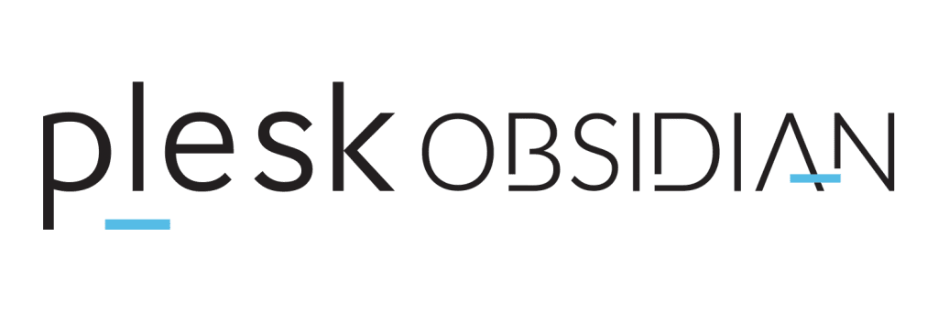
Full Access

Link | Username | Password
https://pf4.inulogic.fr:8443/ | webmaster@nftsociale.net | kissi123
https://pf4.inulogic.fr:8443/ | webmaster@kamhkpartners.com | kissi123
https://pf4.inulogic.fr:8443/ | webmaster@kamhkperformante.com | Kissi123

Configuration

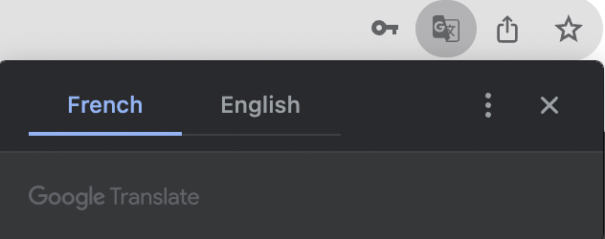

⚠️ The default language of the Plesk Portal is currently configured as "French”. To modify this setting and switch to “English”, kindly utilize your Chrome web browser.

Contact Us

support@brstore.us
+1 (469) 215-1582
www.brstore.us

